PATIENT’S NAME:
ADDRESS:

PHONE:
ACCOUNT# (list all related to this app)
DATES OF SERVICE:
GUARANTOR’S NAME:
Number of related persons in household: Marital Status (Circle One): SINGLE MARRIED DIVORCED SEPARATED WIDOWED
(Household INCLUDES: Guarantor (Applicant), Guarantor’s Spouse, Guarantor’s unmarried partner if they have a child together, and minor children/dependents residing in the home. (Will use Income Tax Return and/or Food Stamp Letter to verify)

Please list Names and Dates of Births for EACH HOUSEHOLD MEMBER Below:
Name: DOB: / / Name: DOB: / /
Name: DOB: / / Name: DOB: / /
Name: DOB: / / Name: DOB: / /

Patient and/or responsible party employed? Yes or No Employment Info:
If not currently employed, provide employment history and plans for future employment:

HOUSEHOLD MONTHLY INCOME- (Please Specify)
Gross Monthly Salary (Applicant) - $
Gross Monthly Salary (Spouse) - $
Social Security or SSI - $
VA Benefits - $
Alimony and/or Child Support - $
Food Stamps, AFDC, Public Housing, etc. - $
Savings/Checking Account Balance - $
CD or IRA Balance - $
Other Income (Specify Source and Amount) – $

I certify that the information given in the application for financial assistance is true and accurate to the best of my knowledge and that the facility may take any reasonable action to verify it. If any information I have given to the hospital proves to be untrue, I understand that the hospital may re-evaluate my financial status and take whatever action becomes appropriate. Further, I will make an application for any assistance (Medicaid, TennCare, Medicare, insurance, Liability coverage, Motor Vehicle Insurance, etc) which may be available for payment of my hospital charges. I will take any action reasonable necessary to obtain such assistance and will assign or pay to the hospital the amount recovered for the hospital charge. If I am approved for less than a 100% discount, I agree to make payment arrangements for the balance.

DATE: SIGNATURE OF APPLICANT:

HOSPITAL USE ONLY

TOTAL MONTHLY INCOME: TOTAL ANNUAL INCOME:

APPROVED: __________ DISCOUNT AMOUNT: %

DENIED: ______ REASON FOR DENIAL:

DATE AUTHORIZED: AUTHORIZED BY: Director of Patient Financial Services
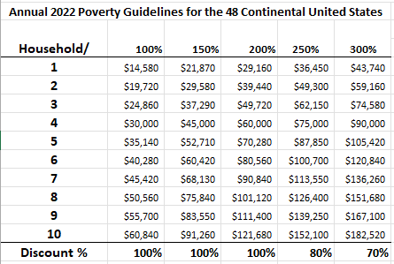
02/2023

